# CHAPTER 2

# REQUIREMENT ANALYSIS

## 2.1 DATA FLOW DIAGRAM

The schema represents the Medical Clinic Database Management as shown in fig 2.1

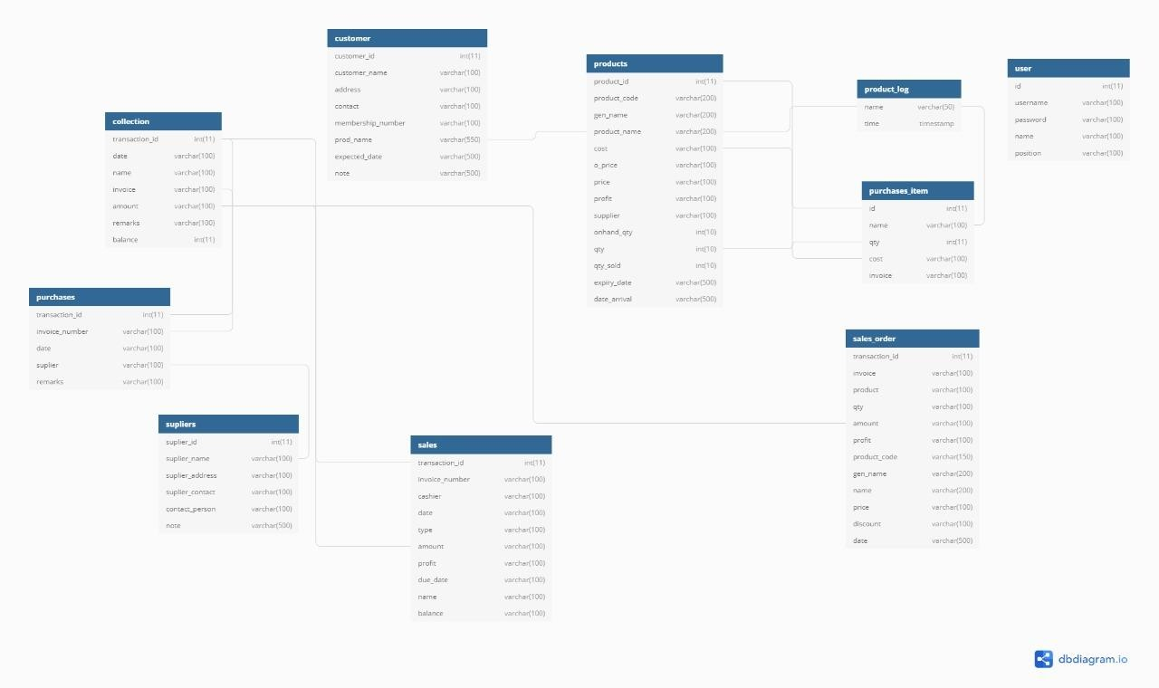

**Fig 2.1: Data Flow Diagram for Medical Clinic**